Project Executable Files
Date | 25-09-2026
Team ID | SWTID-2026-2919
Project Name | AI FitTrack
Maximum Marks | 3 Marks

Project Executable Files
This section includes the source code and configuration files required to run the AI FitTrack project. The project is developed as a Node.js and Express.js backend application with MongoDB and Google Gemini AI integration.

Step 1: Submission Checklist
S.No. | Item to Submit | Submitted (Yes / No / NA)
1 | Complete source code (all files and folders) | Yes
2 | README / Setup Guide | Yes
3 | package.json / Dependency file | Yes
4 | Database schema / seed files | Yes
5 | Environment configuration file (.env.example) | Yes
6 | Deployed application URL | NA
7 | APK / Executable binary | NA
8 | Dockerfile / Containerization config | NA
9 | Test files and test results | Partial
10 | Demo video or walkthrough | NA

Step 2: File / Folder Structure
The AI FitTrack project follows a modular folder structure to make the source code easy to understand, maintain, and extend.
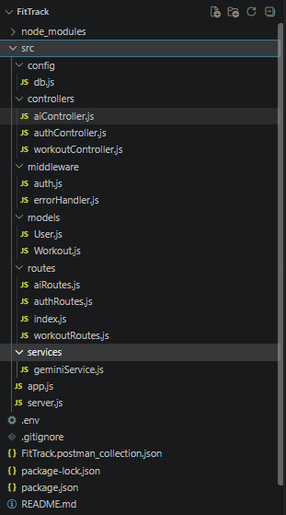

Step 3: Deployment / Access Details
Field | Details
Hosted / Deployed URL | Not deployed (runs locally)
Login Credentials (Demo) | Create an account using the registration API.
Platform / Hosting Provider | Local development environment
Repository Link | [Paste your GitHub repository link here]
Demo Video Link | Not available

Step 4: Run Instructions
Follow these steps to run the AI FitTrack project locally.
Step 1: Install Node.js
Download and install Node.js on your computer.
Step 2: Download the Project
Clone the GitHub repository or download and extract the project source code.
Step 3: Open the Project
Open the project folder in Visual Studio Code and navigate to the server directory.
Step 4: Install Dependencies
Open the terminal and execute:
npm install
Step 5: Configure Environment Variables
Create a .env file using .env.example as a reference. Add the required MongoDB connection string, JWT secret, and Gemini API key.
PORT=5000
MONGO_URI=your_mongodb_connection_string
JWT_SECRET=your_jwt_secret
GEMINI_API_KEY=your_gemini_api_key
Step 6: Start the Application
Run the following command:
npm run dev
Step 7: Verify the Application
The server should start on port 5000. The API can be tested using Thunder Client in Visual Studio Code.

Step 5: Known Issues / Limitations
S.No. | Known Issue / Limitation | Workaround / Status
1 | The application requires a valid MongoDB connection. | Configure the MongoDB connection string in the .env file.
2 | AI recommendations depend on the availability of the Google Gemini API. | Configure a valid API key and retry if the service is temporarily unavailable.
3 | The project currently provides a backend API without a separate frontend interface. | API endpoints can be tested using Thunder Client.

Conclusion
The AI FitTrack project includes the source code, dependency configuration, and setup instructions required to run the backend locally. The modular structure supports maintenance and future development. The application can be accessed through its API endpoints after configuring the required environment variables.

